**ASSIGNMENT-4**

|  |  |
| --- | --- |
| **Student Name** | **ILAKKIYA S** |
| **Student Roll Number** | **921319104063** |
| **Batch No** | **B7-1A3E** |

# 

# Question 1:

Pull an image from docker hub and run it on docker playground.

# Solution 1:

docker pull uifd/ui-for-docker

docker run -d -p 9000:9000 --privileged -v

/var/run/docker.sock:/var/run/docker.sock uifd/ui-for- docker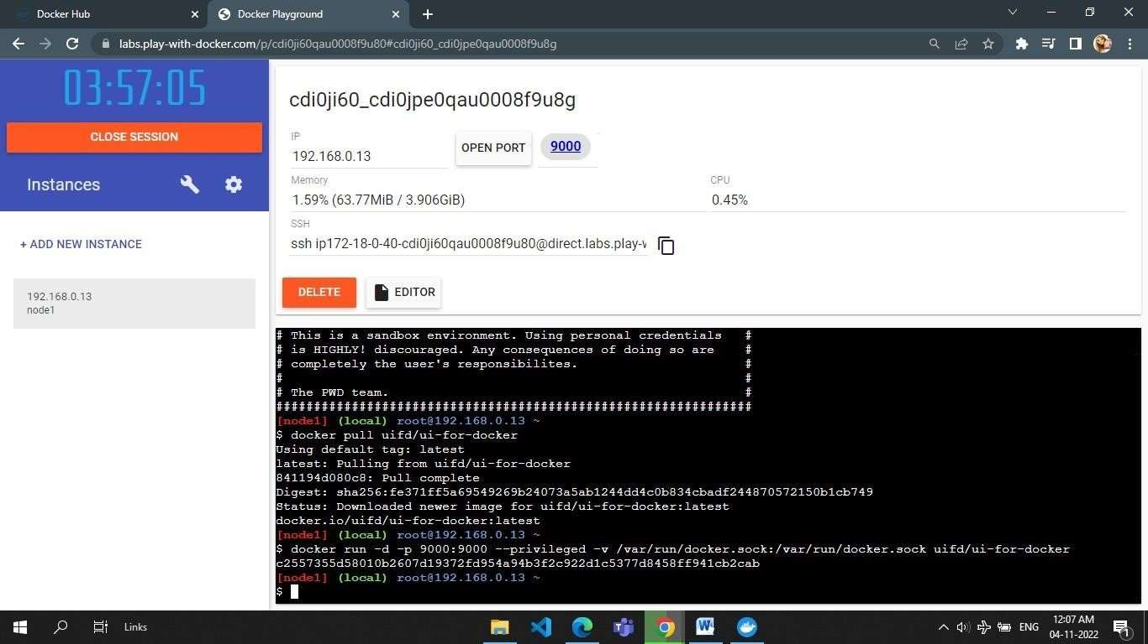

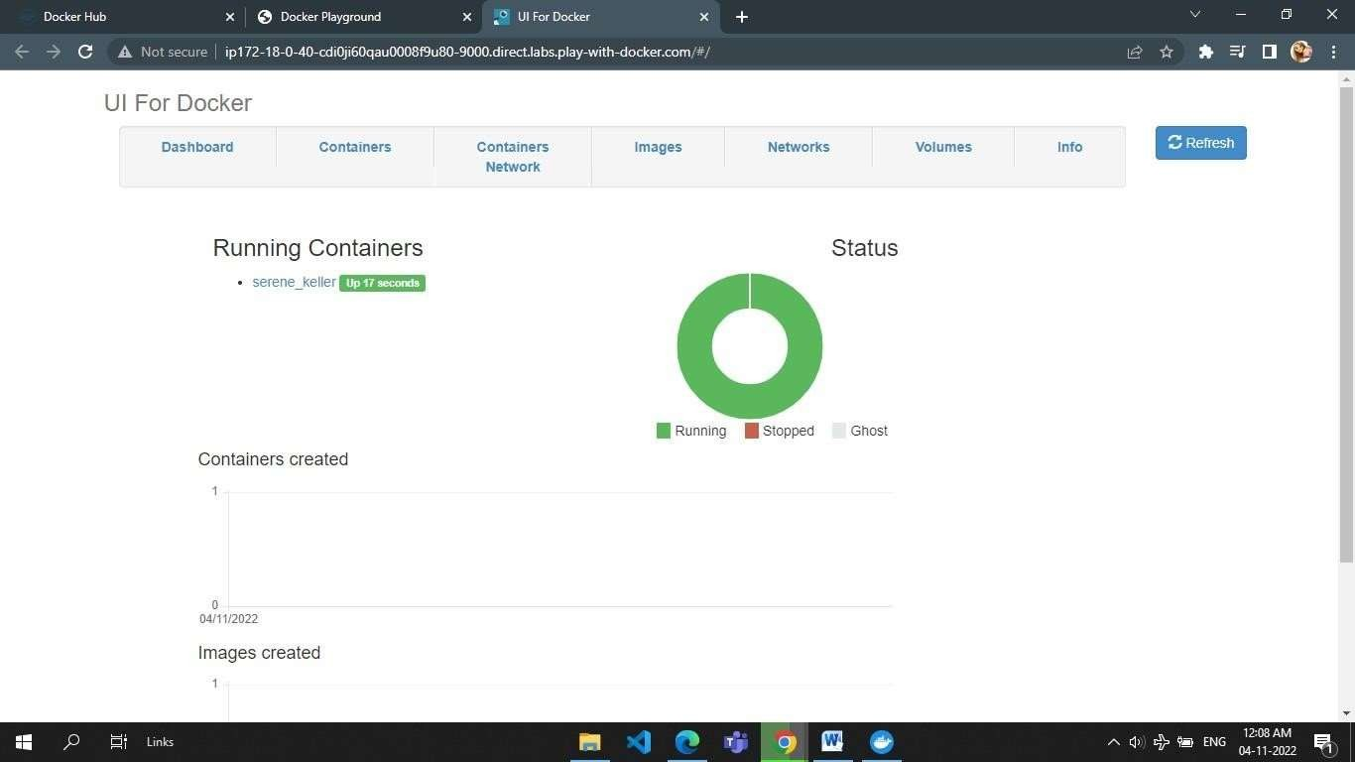

# Question 2:

Create a docker file for the job portal app or hello world app and deploy it docker desktop app.

**Solution 2:**

# Docker file

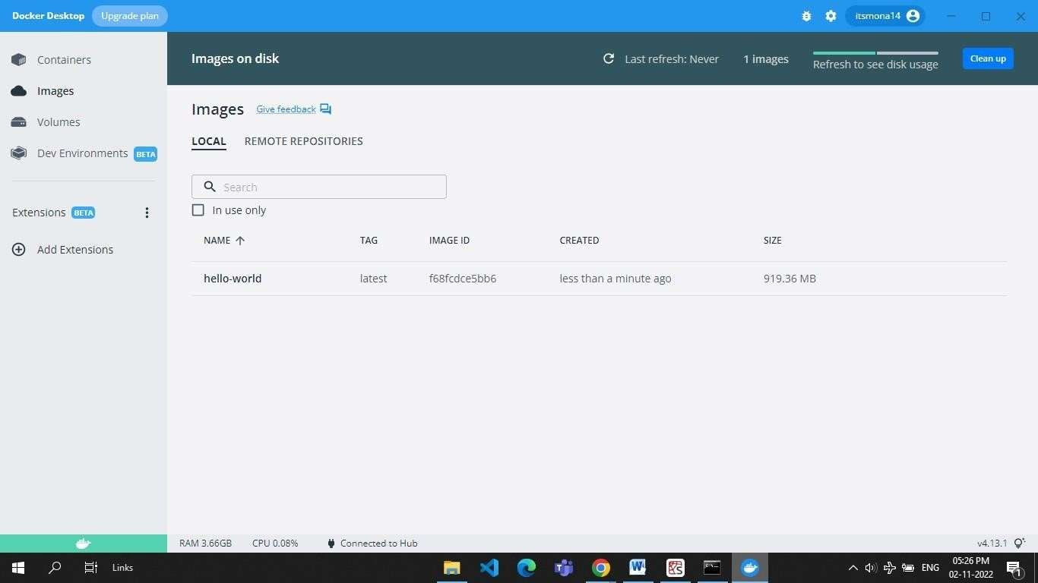

**Question 3:**

Create an IBM container registry and deploy hello world app or job portal app.

**Solution 3:**

**My image link:** au.icr.io/hello-world-app/hello-world

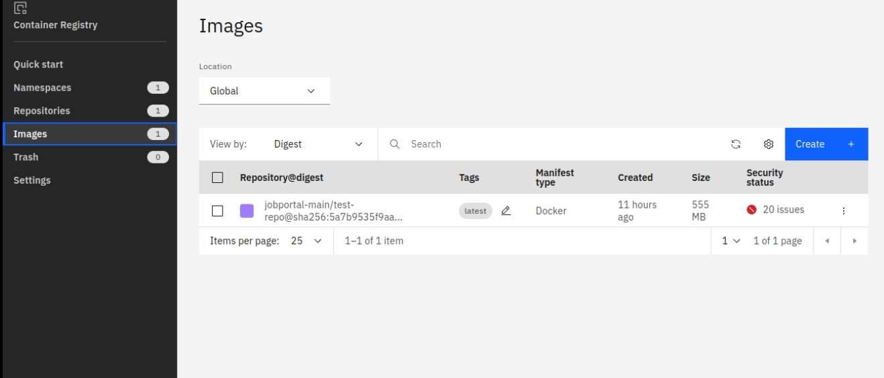

# Question 4:

Create a kubernetes cluster in IBM cloud and deploy hello world image or job portal image and also expose the same app to run in node port.

# Solution 4:

apiVersion:

v1 kind:

Service metadata:

name: hello-world- deployment spec:

ports:

- port: 5000

targetPort: 5000 selector:

app: hello-world

---

apiVersion: apps/v1 kind: Deployment metadata:

name: hello-world- deployment spec:

replic as: 1 select or:

matchLabels: app: helloworld

template: meta

da ta

:

la be ls

:

app: hello- world spec:

containers:

* name: hello-world image: au.icr.io/hello-world- app/helloworld imagePullPolicy: Always ports:
* containerPort: 5000

